7.39: a) At constant speed, the upward force of the three ropes must balance the force, so the tension in each is one-third of the man’s weight. The tension in the rope is the force he exerts, or 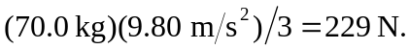 b) The man has risen 1.20 m, and so the increase in his potential energy is 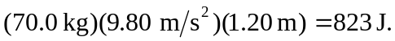 In moving up a given distance, the total length of the rope between the pulleys and the platform changes by three times this distance, so the length of rope that passes through the man’s hands is 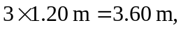 and 